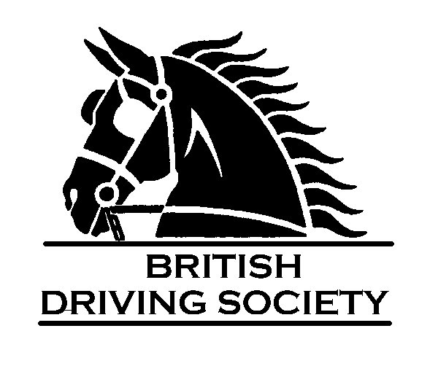
Oxfordshire Area

HOOK NORTON BREWERY JUBILEE DRIVE
SUNDAY 31ST JULY 2022

Name of Owner ..........................................................................................Mr/Mrs/Miss

Name Horse/Pony/Donkey .............................................................………………………………..

Height ................ Single Pair Tandem Team (Please delete as appropriate)

Name of Whip (if different) ……………........................................………….…..........................

Address ................................................................................................................................................................

...........................................................................................................................................................

Post Code .............................................................. Tel No…………………………….

Mobile……………………….E-mail address…………………………………………………..

Name and Age of Young Driver ............................................................................................

BDS Membership Number/s ………………………………………………………………………………………
If Non-Member
Name of Insurer………………………………………… Valid to………………Policy No ……………………..
Please enclose a photocopy with your entry and bring the original to the event.
Has your horse/pony been in contact with any infectious diseases during the last 3 months? Yes /No (Please delete as appropriate)
Signed ..................................................................

Please return completed form with Donation (minimum £10). The donations are in aid of Thames Valley Air Ambulance (PLEASE DO NOT MAKE CHEQUES PAYABLE TO THIS!!)

Anne Deanus 300 Northview, Swanley, Kent BR8 7TD 07768 128229
Cheques payable to BDS Oxfordshire or Bank Transfer to British Driving Society Oxfordshire Sort Code 30-99-78 Account No 01568578. Please ensure you quote the Name of Owner to help identify.
CLOSING DATE 23RD July 2022

